St Joseph’s Catholic Primary School

‘Following Jesus in all we do’

Accessibility Plan

2018-2019

Contact Details

Head Teacher

Mrs Louise Bury

St Joseph’s Catholic Primary School

Chedworth Drive,

Warndon

Worcester

WR4 9PG

Telephone 01905 452772

Email: office@st-josephs-pri.worcs.sch.uk

Accessibility Plan 2018-2019

Key | Accessible Route |  | Accessible Lift |  | Disabled facilities

The accessibility Plan is available to download on the school’s website or a paper copy can be obtained from the school’s office.
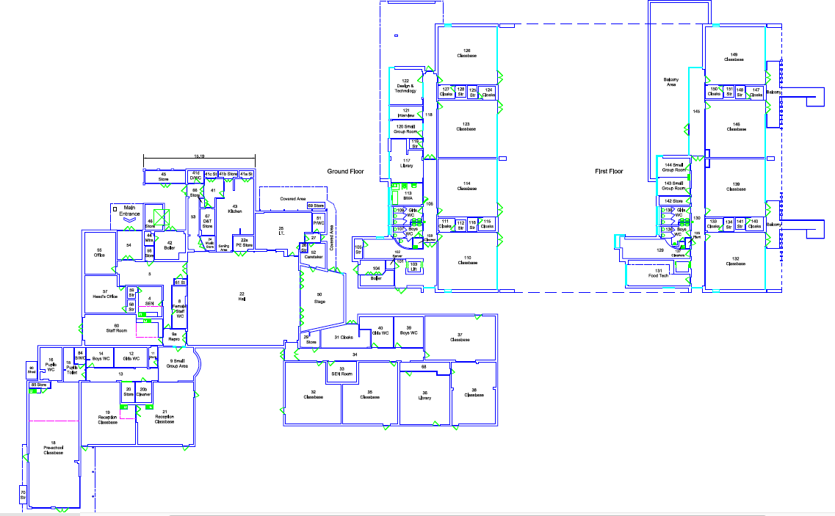

Ref | Removing Barriers: | Recommendations | Time Scale | Cost Implications | Date completed
1. | Corridors | Keep corridors clear from obstructions |  | None | On-going
2. | Wheelchair access into Building 1 (Key Stage One) | At Present access can only be gained via the front entrance of the school  Further Development:  A permanent ramp to be installed at side entrance to replace the portable ramp used on request.  Please also refer to site plan | Within 24 months | Price to be sourced
3. | Wheelchair access into Building 2 (Key Stage Two) | At Present access can be gained via the main entrance, the fire exit at lower ground floor and all lower key stage two-classroom doors.  No further development required.  Please also refer to site plan | N/A | None | N/A
4. | Access to Lift in Building 2 | Access to the lift can be found at the main entrance of building 2.  Please also refer to site plan | N/A | Maintenance costs | On going
5. | Wheelchair access around the site. | Front and rear entrance of the school: Wheel chair access around the whole outside of the building can be accessed.  Further Development:  At present the school field can only be accessed via the car park through locked gates, which leads directly onto the grass.  A small ramp needs to be installed from the paved area outside lower key stage two classroom doors onto the field. | Within 24 months | Price to be sourced
6. | Disabled Parking | The school has one allocated disabled parking zone outside the main entrance. | N/A | Maintenance costs | On going
7. | Disabled Toilets in Building1  (Key Stage One) | There is currently one disabled toilet in building 1.  Please also refer to site plan | N/A | Maintenance costs | On going
8. | Disabled Toilets in building 2  (Key Stage Two) | There is currently one disabled toilet in building 2  Please also refer to site plan | N/A | Maintenance costs | On going
9. | Changing and shower facilities | There are changing facilities and showering facilities in building 2.  Please also refer to site plan | N/A | Maintenance costs | On going
10. | External Steps | Mark steps with yellow highlighting paint on all the external steps to be maintained  Unable to access Key Stage One Classrooms from Key stage one playground this needs to be considered. | Within 24 months | Price to be sourced

